http://www.facultyfocus.com/

July 6th, 2015

How a Course Map Puts You on Track for Better Learning Outcomes
By: Vicki Caruana, PhD

For both new and veteran faculty, inheriting a syllabus to teach from is like being blindfolded on a long journey and being told, “Don’t worry, you’ll know it when we get there.” There’s a lot of trust required in order to follow someone else’s map. There are road hazards the mapmaker may not be aware of; there may be alternate routes that might get you there more directly; and it may even be prudent to choose another mode of transportation to get there.
More often than not, when I follow someone else’s syllabus, I get lost along the way and sometimes don’t end up at all where I thought we would be at semester’s end. In order to effectively meet the expected course outcomes and/or student learning outcomes (SLOs), it’s important to have a well-thought-out course map.
Course mapping, as a step in the curriculum mapping process (Jacobs, 2004), offers faculty new pathways to meet shared outcomes. The five principles of curriculum design (Fink, 2003) inform the development of learning experiences that are structured in such a way that they scaffold student thinking and progressively move them toward the desired course outcomes. A course should: (1) challenge students to higher level learning; (2) use active forms of learning; (3) give frequent and immediate feedback to students on the quality of their learning; (4) use a structured sequence of different learning activities; and (5) have a fair system for assessing and grading students.
In addition, employing the principles of backward design, we can (1) provide more relevant and meaningful learning experiences; (2) ensure that the required course outcomes are met; and (3) prepare students to perform successfully on their final assessment. One starts with the end—the desired results (goals or standards)—and then “derives the curriculum from the evidence of learning (performances) called for by the standard and the teaching needed to equip students to perform” (Wiggins & McTighe, 2000).
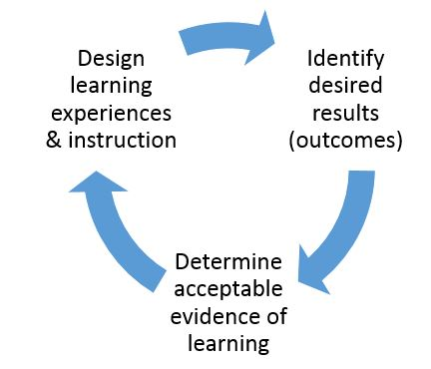
The first step is to clearly define the course outcomes. If they have already been provided to you, then begin with unpacking those outcomes so that you clearly understand what is expected of your students by course end. Each outcome is a destination. Ideally, each destination will have its own map. Both faculty and students should be aware of the essential knowledge and skills that they should be able to demonstrate by the end of the course. Find ways to make these outcomes transparent and accessible for students. Just because they are listed in the course syllabus does not ensure students will read or even recognize them as a part of their learning experience in your course.
The second step is to identify and design assessment methods. Design both formative and summative assessment methods in such a way that they build on one another and point directly to course outcomes. List the outcomes and designate a formative or summative assessment as a measure of that outcome.
Often a summative assessment will target one or more of the course outcomes. As you consider all the ways in which your students will demonstrate that they have met the course outcomes with an assessment, you can begin to plan your route to your final destination by designing learning experiences and selecting effective instructional strategies that get you there successfully. The goal is to provide assessments and feedback that align and are sequenced or scaffolded along with the other course components (Meyers & Nulty, 2009). For more information on scaffolding student learning, read Scaffolding Student Learning: Tips for Getting Started. (http://www.facultyfocus.com/articles/instructional-design/scaffolding-student-learning-tips-for-getting-started/
The final step is to plan learning experiences and instructional strategies. If you inherited a course syllabus, often there are learning activities already included for you to use—or not. It’s important to take inventory of the learning activities provided and determine whether they are appropriate to use as navigational tools to guide your students in the direction of the desired course outcomes and deeper engagement of the material. Meyers and Nulty (2009) offer five principles to design quality learning experiences that: (1) are authentic and relevant; (2) are constructive, sequential, and scaffolded; (3) require students to engage in higher-order thinking; (4) are aligned with each other and the course outcomes; and (5) are challenging, interesting, and provide motivation to learn.
The following table presents a framework to communicate the alignment of course outcomes with assessments and learning experiences, as well as how the course outcomes fit within the context of the program. This framework can be used to create your course map as well as communicate its alignment to colleagues and students.

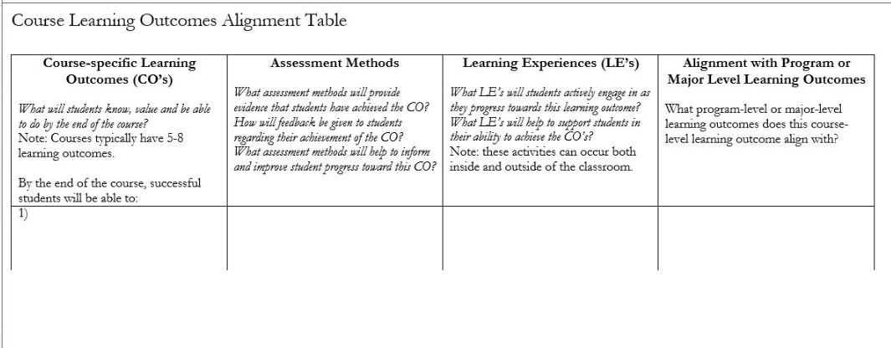
References
Fink, L.D. (2003). Creating significant learning experiences. San Francisco: Jossey-Bass.
Jacobs, H.H. (2004). Getting results with curriculum mapping. Alexandria, VA: Association for Supervision and Curriculum Development.
Kenny, N., & Watson, G. (2014). Course alignment table. Open Learning and Educational Support, University of Guelph. Retrieved from http://creativecommons.org/licenses/by-nc-sa/4.0/
Meyers, N. M., & Nulty, D. D. (2009). How to use (five) curriculum design principles to align authentic learning environments, assessment, students’ approaches to thinking and learning outcomes. Assessment & Evaluation in Higher Education, 34(5), 565-577.
Wiggins, G., & McTighe, J. (1998). Understanding by design. Alexandria, VA: Association for Supervision and Curriculum Development.
Vicki Caruana is an assistant professor of education at Mount Saint Mary College.

