

USI Training Manual:

Watermark Student Learning & Licensure (SLL)


Contents

Introduction 4
Student Resources 4
Header and Navigation Menu 4
In Progress Tab 4
Accessing an Activity 4
Activity Template 5
Directions to begin or continue an activity/ assignment: 5
Uploading Files 6
Saving and Submitting Your Work 6
To attach one or more files from your device to an activity, please follow these steps: 6
To withdraw a submitted activity: 7
To view a completed assessment: 7
Timeline Tab 7
ePortfolios Tab 8
Profile Tab 8
Submitting Time Logs 8
Progress Tab 8
Getting Help 10
Faculty Resources 11
Logging In 11
LMS Integration Setup 11
Blackboard Ultra Integration Process 11
Important Notes for Blackboard Ultra: 13
Rubrics 13
Requesting New Rubrics or Updating Rubrics 13
Scoring Rubrics 13
Accessing Student Submissions and Assessing Activities 14
Through Watermark SLL: 14
Through Your LMS: 14
Scoring Process 14
Providing Student Feedback 15
Undoing Assessments and Requesting Revisions 15
To Undo a completed assessment: 15
Force Submit and Rollback 16
Force Submit 16
Rollback 17
Bulk Assessment of Student Submissions 17
Assessment Reporting 19
Exporting the Assessment Results 21
Scores Tab 22
Troubleshooting 22
LMS Integration Problems 22
Scoring Challenges 22
Student Access Issues 23
Getting Help 23
Mentor and Supervisor Resources 24
In Progress Tab 25
Internship Details Page 25
To assess a submission: 27
Student Logs 28
Getting Help 29
Watermark Training Video Links 29

Introduction
Watermark Student Learning & Licensure (SLL) is a comprehensive assessment platform designed to streamline the collection, scoring, and analysis of student performance data. This training manual will guide faculty through the process of setting up LMS integration and effectively scoring rubrics within the platform. Resources, including videos, can be found on the USI Watermark page at Watermark Student Learning and Licensure - University of Southern Indiana.

Student Resources

Header and Navigation Menu
After logging in, you will see a header at the top of the page indicating the Watermark product you are currently using. On the right side of the header, you will find several icons:
- Question Mark Icon: Redirects you to Watermark's Help Center for assistance.
- Bell Icon: Allows you to view your notifications.
- Grid Icon: Use this to log out of your Student Learning & Licensure account.
On the left side of the screen, you will find a navigation menu that includes:
- In Progress
- Timeline
- ePortfolios
- Profile

In Progress Tab
The "In Progress" tab is your default display after logging in. Here, you can access your courses and course activities. After logging in, the Progress tab will list all of a student's open courses. For each individual course, activities ready to be started or continued will be listed with the course information.
Please note, if you do not see the course you are attempting to submit to, please contact your institution directly regarding the course or internship.
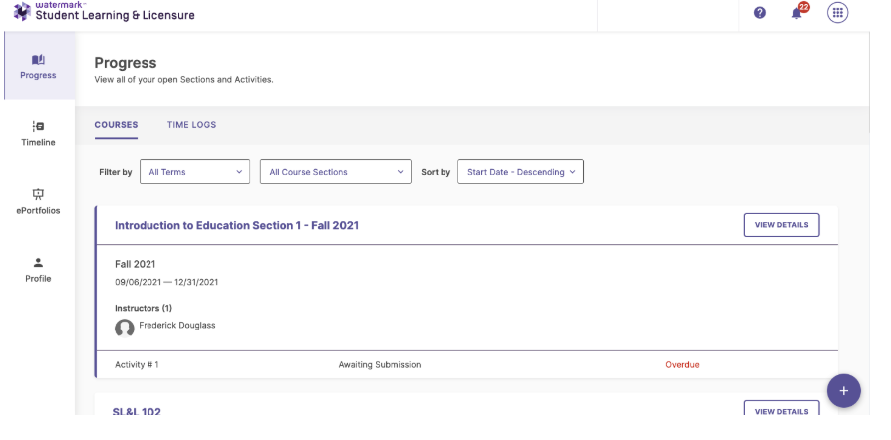

Accessing an Activity
You can access an activity in one of three ways:
- Click the name of the course, then select the appropriate activity from the list.
- Click the "View Details" button, then select the appropriate activity from the list.
- Select the name of the activity located directly under the course section on the "In Progress" tab.
Clicking on an individual course will display the course activity tab. The course activity tab allows a student to view, begin, or continue activities. If an activity has been assessed, the student can also see the results of the assessment. The course details tab also provides access to the course homepage.
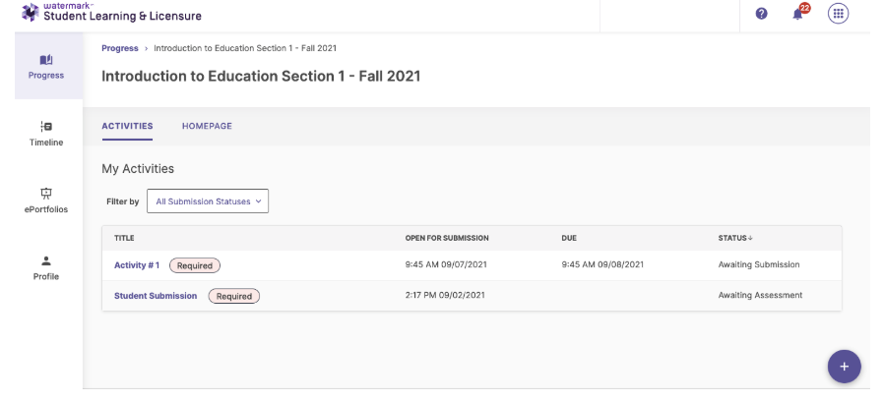

Activity Template
Once you click on an activity, you will navigate to the activity template. Here you can provide requested materials, such as:
- Student work samples
- Free text
- Exam or quiz style responses

Directions to begin or continue an activity/ assignment:
- From the Progress tab, or from a course details page, click on the activity to be completed.
- Populate any required fields and provide any necessary information.
- Click the SAVE button to save all work, and return to the activities list, or click SUBMIT to complete the activity submission.
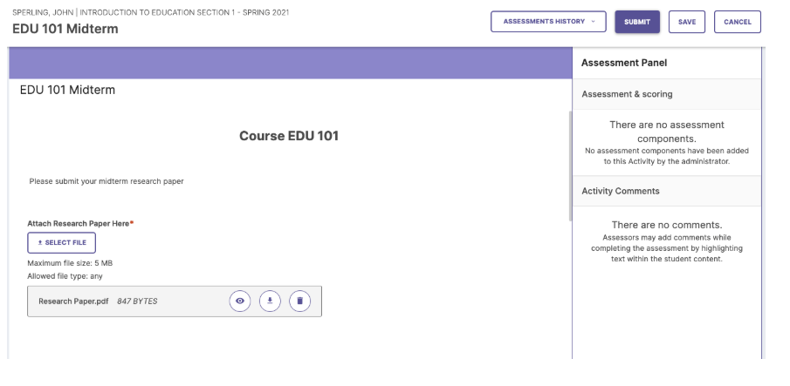

Uploading Files
You can upload external files from your local drive by clicking "select file" and then "add file". You also have the option to use "Previous Upload," "Dropbox," or "Google Drive" tabs.

Saving and Submitting Your Work
- Cancel: To exit an activity without saving changes, click the "Cancel" button in the upper right corner.
- Save: To save your work and return later, click the "Save" button.
- Submit: To save your work and submit for grading, click the "Submit" button.

To attach one or more files from your device to an activity, please follow these steps:
- Access your student account
- From the Progress tab, click on the name of the course where you are attempting to submit.
- Click on the title of the activity.
- If you need to attach a file, then your instructor would have created an attachment component. This will appear as a "Select File" button. Click this button to select a file. Note: If you do not see the "Select File" button available within the activity, please contact your instructor directly. They would need to make this button available to you before you can attach a file.
- In the attachment window that opens, select Local File.
- Click the "Choose File" button.
- In the window which opens, find one file on your device that you would like to attach and click "Open".
- Repeat steps 6 and 7 as needed to attach more files.
- Click the "Insert" button to attach the selected file(s) to the activity.

To withdraw a submitted activity:
- From the Progress tab, or from a group details page, click on the activity to be withdrawn.
- Click the WITHDRAW button.
NOTE: Not all submitted activities can be withdrawn. Below are the four reasons the WITHDRAW button will be greyed out:
- The assessor has begun the assessment process.
- The withdraw feature was disabled for the activity when it was created.
- The activity due date has passed.
- The course end date has passed.
If you are unable to withdraw but you need to make changes to your submission, please contact your instructor.

To view a completed assessment:
- From the Progress tab, or from a course details page, click on an assessed activity to view the assessment results.
- Any previous submissions to the activity can be viewed by selecting it from the Assessments History dropdown menu.
- When finished, click Cancel.

Timeline Tab
The "Timeline" tab helps you document achievements throughout your academic journey. When you click on this tab, you will see:
- Work
- Artifacts
- Completed assessments
- Activities awaiting assessment
Click on a timeline entry to view more information about that topic.

ePortfolios Tab
Some activities may require you to curate items from your timeline and other sources into a folio that highlights your accomplishments. For additional help with ePortfolios, refer to the "Creating an ePortfolio" article in the Help Center.

Profile Tab
The "Profile" tab allows you to review your account information. You can also:
- Update your avatar photo
- Change your password
- Select your language preferences

Submitting Time Logs
Time Logs are for teacher candidates to be able to submit their time from their clinical practice. In Watermark™, the term “internship” is used, which means any course that has a field placement.
Progress Tab
After logging in to SL&L, the Progress tab will be shown. The Progress tab will list all of the current courses. Logs are available for each clinical experience enrolled in.
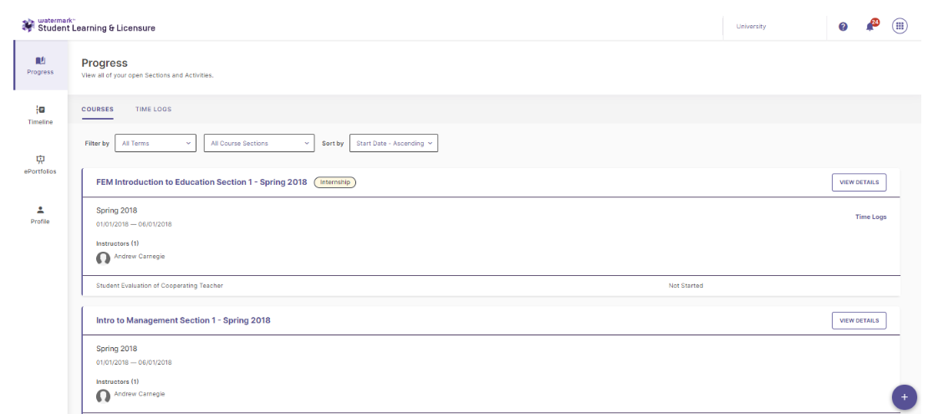
Log
Click on an clinical practice course that is labeled Internship or click on the Time Logs button that is at the far right of any clinical practice course. Clicking on Log will display your previously submitted log hours. The Log Entry page allows you to submit new log hours, or edit hours that have not been approved or rejected. If a log entry has been approved or rejected, you can also see who approved the hours. The Log Entry page also provides access to the course homepage, activities, and your placement details.

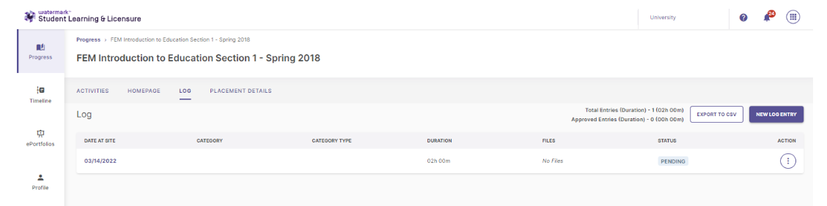

Create Log Entry
On the Log page, select the NEW LOG ENTRY to record a new log entry. You'll first select the date and placement site and then click Create Log Entry. This will bring up a panel on the right side, from which you'll input the category, start time, end time, and description for the hours you're inputting. You may also attach files, if needed. After filling out the mandatory items, you can click Apply.
NOTE: If there are no Categories to select, please contact the Student Learning & Licensure administrator at USI, Dr. Simone Nance, senance@usi.edu.
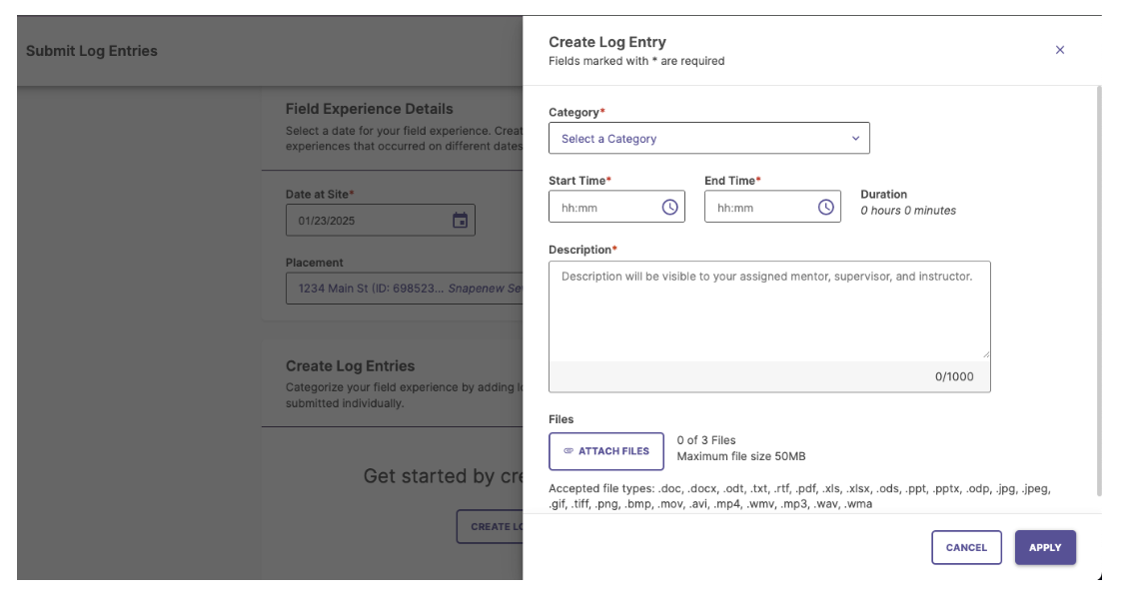

If you have additional logs to enter for the same date, click CREATE LOG ENTRY again. When you are finished adding logs for the selected date, click SUBMIT. Each log entry you have submitted can be approved/rejected by your mentor or supervisor.

Getting Help
Watermark SLL Contact at USI:
- Dr. Simone Nance, Assessment Manager
- Email: senance@usi.edu
- Phone: 812-465-1607
- Office: Education Center 3134

Faculty Resources

Logging In
- Open your web browser and navigate to myUSI portal.
- Log in using your institutional SSO credentials.
  - SSO URL
- Click on the "Watermark" tab in the myUSI portal.
- Select "Student Learning & Licensure" from the Watermark options.

LMS Integration Setup
Watermark SLL integrates with Blackboard Ultra at USI. Setting up this integration allows for seamless assignment submission and assessment.

Blackboard Ultra Integration Process
- Log in to your Blackboard faculty account and navigate to the Content page for your course.
- Click the "+" icon, then click "Content Market".
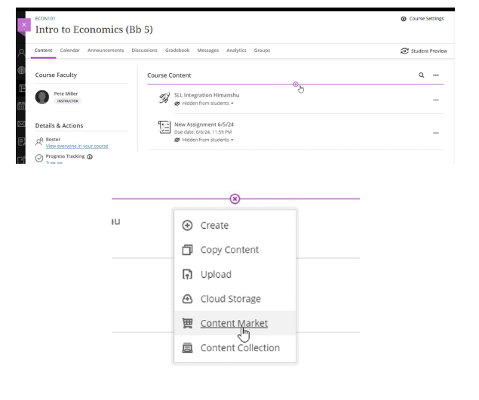
- Scroll down to the list of Institution Tools and find the “Watermark Student Learning & Licensure” tool that was added by your administrator, then click the plus icon. This will add a link to the Content page of your course.
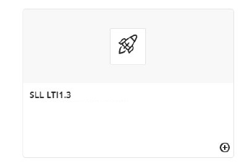
- Click the "More options" button (three dots) to the right of the link and click "Edit Activity".
- Change the title of the link to something descriptive for your students.
- Select "Visible to students".
- Click the "Create gradebook entry for this item" checkbox if you want grades to synchronize back to Blackboard.
- Click "Save".
- Click on the link.
- Choose the "Specific Activity" option.
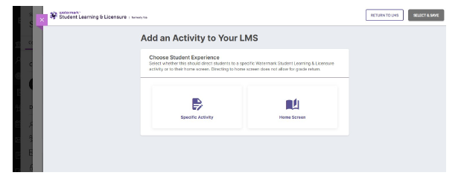
- Choose a course section and activity from SL&L and click "SELECT & SAVE" in the upper right corner of the page. 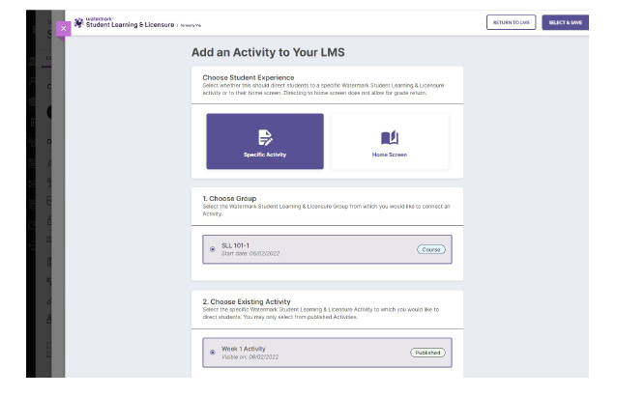
- A Success message will be displayed on the page. Click "RETURN TO LMS". Clicking the link on the Content page in your Blackboard course will now take you directly to the SL&L activity.

Important Notes for Blackboard Ultra:
- Ensure the assignment is marked as "Visible to Students" when you are ready for them to access it.
- You can edit the assignment settings after creation by selecting the assignment and clicking the "Edit" option.
- Use the "Student Preview" feature to verify the integration appears correctly to students.

Rubrics

Requesting New Rubrics or Updating Rubrics
If you need a rubric that is not available, or a change/update is needed to a current rubric:
- Contact your department's Watermark administrator, Dr. Simone Nance.
- Provide details about the assessment needs. Include revised/new rubric and student instructions. Include alignment to appropriate standards.
- Work with the administrator to develop or import appropriate rubrics and template.

Scoring Rubrics
Effective rubric scoring ensures consistent assessment across faculty and provides valuable data for program improvement.

Accessing Student Submissions and Assessing Activities

Through Watermark SLL:
- From the In Progress screen, click on the title of the course that contains the activity you would like to assess.
- Click on the title of the activity.
- Click on the name of the student you would like to assess.
NOTE: If the student is still in the Awaiting Submission status, you will not be able to submit an assessment. If the student is not required to submit the activity, the Force Submit tool can be used to move the student to Awaiting Assessment status.

Through Your LMS:
- Log in to your LMS.
- Navigate the assignment.
- Click on the student submission.
- The Watermark scoring interface will open automatically.

Scoring Process
- Review of the Student Submission
  - View the submitted document, project, or performance.
  - Reference any supporting materials.
- Access the Scoring Rubric
  - The appropriate rubric will automatically appear in the scoring panel.
  - Review the criteria and performance levels before beginning.
  - TIP: Hover over cells in rubric to see the performance level, element name, and description.
  - TIP: Clicking View Rubric Details will open an expanded version of the rubric in a new tab, showing all level and element names, as well as descriptions.
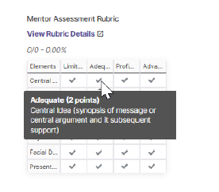
- Evaluate Each Criterion
  - For each criterion, select the appropriate performance level.
  - Click on the cell that best represents the student's performance.
  - The selected cell will highlight to confirm your selection.
- Add Comments (Optional but Recommended)
  - Click the comment icon for any criterion to add specific feedback.
  - Provide constructive comments that explain your assessment.
  - Consider addressing strengths and areas for improvement.
- Adding Embedded Comments to Student Work
  - On the assessment page, double click or highlight any word or area in a submitted template.
  - Click the comment icon that appears.
  - Type a comment into the Comment text box.
  - When finished, click the checkmark icon.
- Complete the Assessment
  - Fill out all required components (Rubrics, Feedback, Scores, etc.).
  - After completing the assessment, click the Save button to save your work and return it to the activity details page.
  - Click the Submit button to finish the assessment process.

Providing Student Feedback
Quality feedback enhances student learning and development.

Adding General Comments
- After scoring all rubric criteria, locate the "General Comments" section.
- Provide overall feedback that synthesizes your assessment.
- Consider addressing:
  - Major strengths
  - Priority areas for improvement
  - Connections to course or program outcomes
  - Suggestions for future work

Attaching Files
- Click the "Attach File" button in the feedback section.
- Select a file from your computer.
- Add a description of the attachment.
- Click "Upload"

Undoing Assessments and Requesting Revisions
To Undo a completed assessment:
1. On the activity details page, click on the assessment in the Done column that needs to be undone
2. Click the Undo button
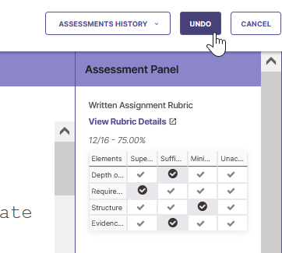
To request that a student resubmit to an activity:
1. On the assessment page, add any comments, feedback, and rubric scoring that should be included as part of the record
2. Click the Request Revision button
Viewing Students’ Previous Submissions
When a student’s submission has been sent back for revision, a record is kept of the initial submission, as well as any comments, feedback, and rubric scoring provided by the assessor. The instructor can view a student’s previous submissions using the Assessments History button, located on the assessment page

Force Submit and Rollback

Force Submit
Instructors can move student submissions forward in the assessment process without requiring students to submit by using the Force Submit tool. The Force Submit tool will move all selected submissions into the Awaiting Assessment column at one time.
To Force Submit one or more student submissions:
- Navigate to your course and click on the title of the activity
- Click the Bulk Actions dropdown
- Click Force Submit
- Select each student you would like to Force Submit, then click the Force Submit button
NOTE: A Force Submit cannot be undone, however the Request Revision tool can be used to allow the student to submit the activity again

Rollback
The Rollback option allows a instructor to move students’ submissions backwards in the assessment process.
NOTE: Using Rollback will clear any work that was done in the activity by students or assessors, and it cannot be undone
To Rollback student submissions:
1. Navigate to your course and click on the title of the activity
2. Click the Bulk Actions dropdown
3. Click Rollback
4. Select the Status you would like to Rollback to, and click Rollback

Bulk Assessment of Student Submissions
The Bulk Assessment feature grants instructors the capability to assign the same scores, assessment feedback, and rubric comments to multiple students simultaneously within specific activities, including Observational Assessments, Assisted Assessment, and Standard Assessment workflows.

To access the Bulk Assessment feature:
1. Click on a course on the In Progress page
2. Click on an Activity
3. Click the BULK ACTIONS dropdown
4. Select Student Assessment
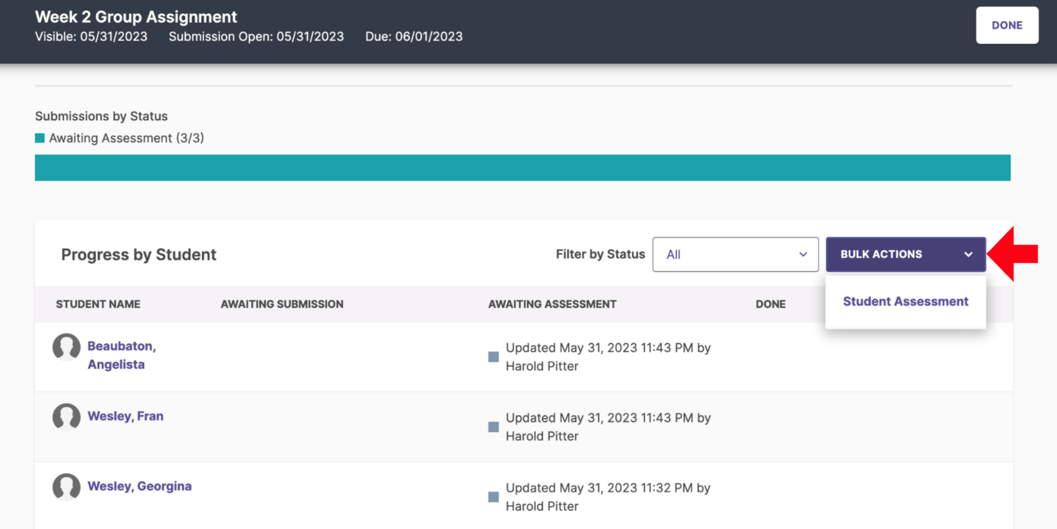

The bulk assessment area will include a list of students awaiting assessments, as well as the activity template used. Any students who have saved assessments will have the date, time, and user who last updated the assessment listed below the students name. Including these students in your bulk assessment will override any saved scores or feedback.

5. Select the students that you would like to include in the bulk assessment
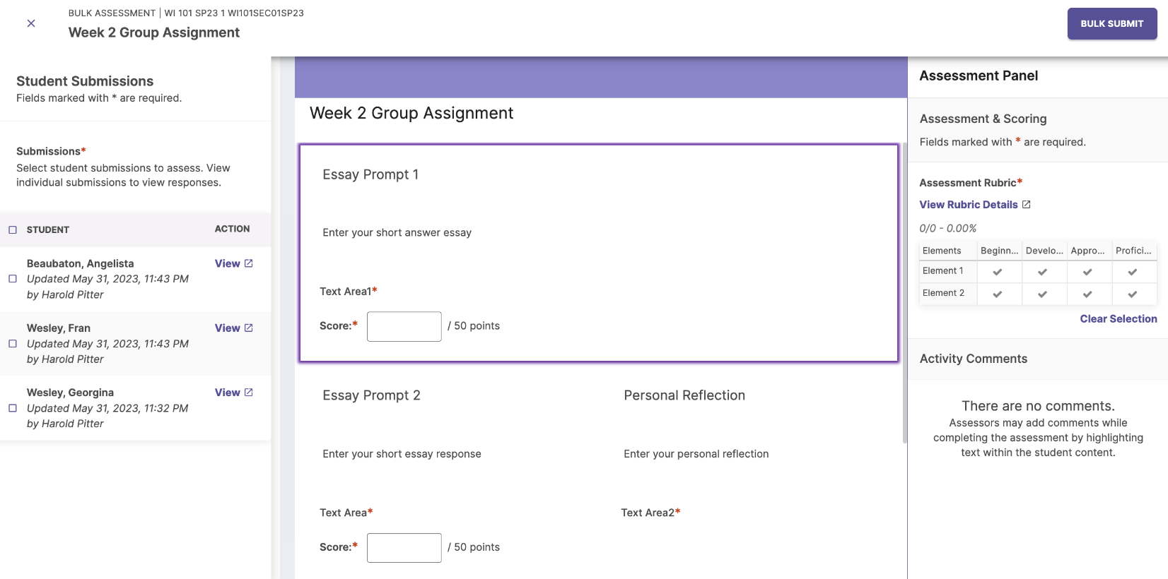
The Student Submissions list will include the students name and either their submission date/time or the date/time and name of the faculty who last updated their assessment. Selecting students with saved assessments in your bulk assessment will override any saved scores or feedback. In bulk assessment mode, any scores recorded in the activity template or the Assessment Panel will be applied to all students selected.

6. To complete the assessment, click Bulk Submit. If any of the students selected have saved assessments, you will be prompted to confirm if you would like the bulk assessment scores and comments to override the saved assessment.

Assessment Reporting
Instructors can run an activity assessment report that will show all assessments that have been completed within the activity, and will show rubric scoring by individual assessor, or by aggregated scores.
To run an activity assessment report:
1. Log in as an instructor
2. Navigate to the activity details page of the assessed activity.
3. Click the View Report link
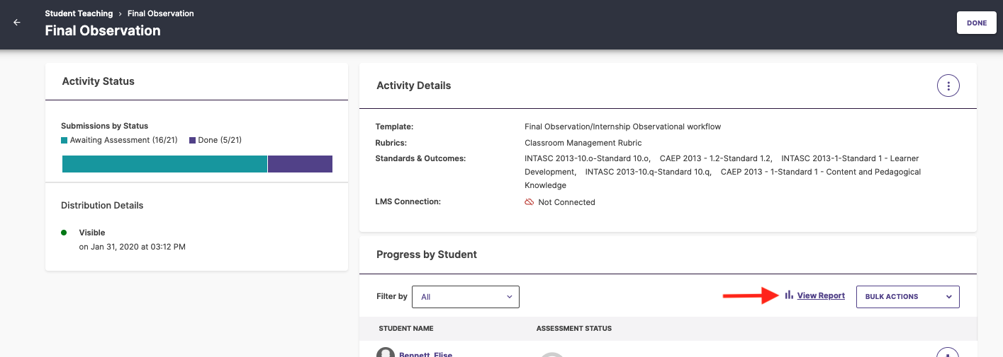
Per Student Report
The Per Student Report lists all students that have been assessed in the activity, all rubrics and rubric elements that have been completed in the activity, and displays the rubric performance level that each student scored for each rubric element.
TIP: To view a student’s assessed submission, click on a student’s name.
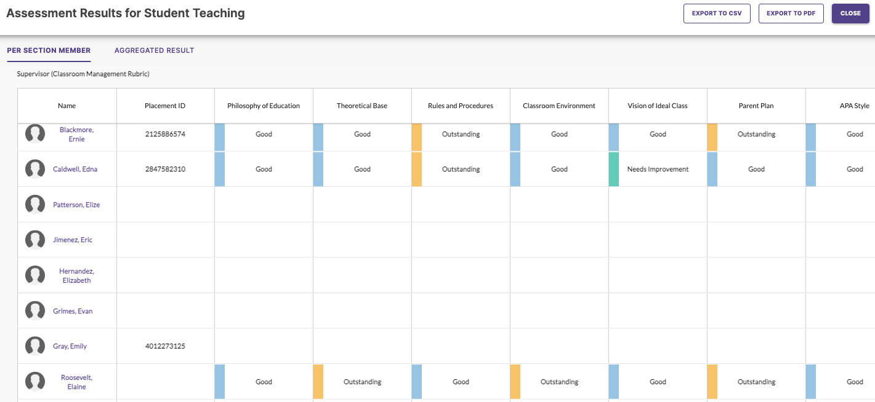
Aggregated Result Report
The Aggregated Results report lists all rubrics and rubric elements that have been completed in the activity, displays the number of times each performance level was scored for each rubric element, and calculates the mean score and standard deviation for each rubric element.
The top half of the report displays scores using colored bars, with each color representing a performance level. The bottom half of the report displays the same scoring information, but in a table format.
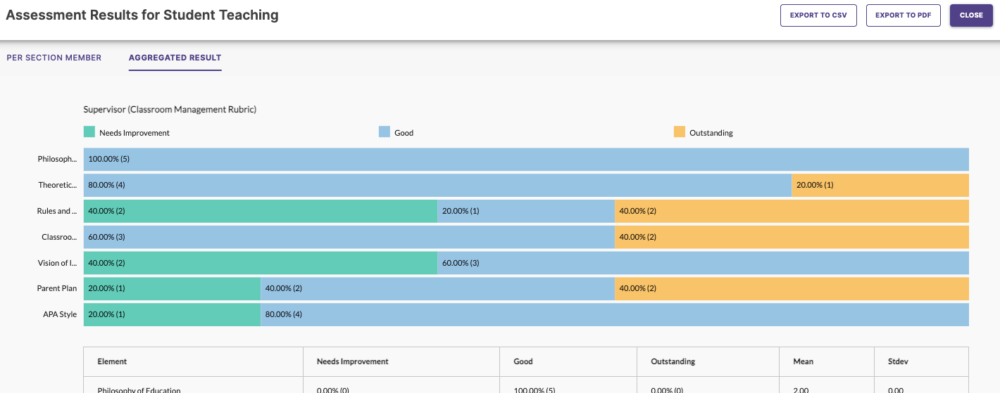
TIP: Clicking on a number will display a list of the students that were assessed at that performance level, the student’s assessor, and the time stamp of the assessment. From this list, clicking on a specific assessment will open the student’s assessed submission.
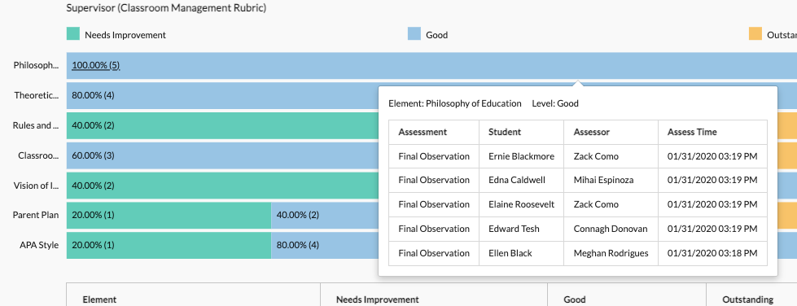
Exporting the Assessment Results
Assessment Results can be exported for archiving, sharing with others, etc. A report can be exported as either a PDF or a CSV file. To export a report, click either the Export to CSV or Export to PDF button.

Scores Tab
On the section details screen, the Scores tab allows instructors to view scoring information for any activities in which scoring was included as part of the assessment. Scoring information is presented in a table showing students, any activities that have been scored, and a total score for each student across all score activities.
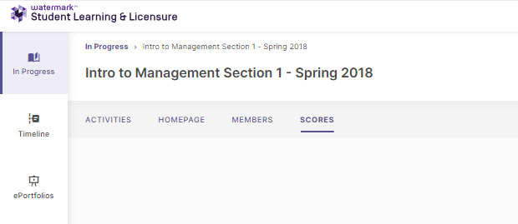
NOTE: For scores to be available in the Scores tab, a score must have been typed into the scoring component included in the assessment panel of a template, and that Scoring component must be set up as Primary Score.

Troubleshooting

LMS Integration Problems
Issue: Watermark SLL does not appear in my LMS external tools list. Solution: Contact your institution's IT support or Watermark administrator to verify integration setup.
Issue: Students cannot access the Watermark submission link. Solution: Verify that the assignment is published and available to students in your LMS.

Scoring Challenges
Issue: Rubric will not load or appear incomplete. Solution: Refresh your browser, clear cache, or try a different browser. If the problem persists, contact support.
Issue: Cannot save or submit scores. Solution: Check your internet connection, ensure all required fields are completed, and try again. If issues continue, take screenshots, and contact support.

Student Access Issues
Issue: Students report they cannot see their feedback. Solution: Verify you clicked "Submit" (not just "Save") and that the release date for feedback has passed.

Getting Help
Watermark SLL Contact at USI:
- Dr. Simone Nance, Assessment Manager
- Email: senance@usi.edu
- Phone: 812-465-1607
- Office: Education Center 3134

Mentor and Supervisor Resources
There are two ways for mentors/cooperating teachers/university supervisors to access their Student Learning & Licensure (SL&L) accounts:
- Click the link in your email notification - Once you are assigned as a mentor/cooperating teacher/university supervisor by USI, you will receive an email notification with a unique link that will take you directly into your SL&L account without having to enter login information. If you do not receive this email or have accidentally deleted it, you may either follow the steps below to log into sll.watermarkinsights.com or contact the Watermark administrator USI and request that they send a new notification email.
Note: emails will come from no-reply@watermarkinsights.com
SLL DIRECT: https://sll.watermarkinsights.com/
- Log in on sll.watermarkinsights.com:
  - Open your web browser and navigate to the URL: sll.watermarkinsights.com
    - (Google Chrome and Firefox are our recommended browsers)
  - Enter your email address and password
    - If this is your first time logging in, click Forgot Password and enter your email address to receive an email with a link to set your password
    - If you do not receive the email please check your spam/junk folder. Emails will come from no-reply@watermarkinsights.com
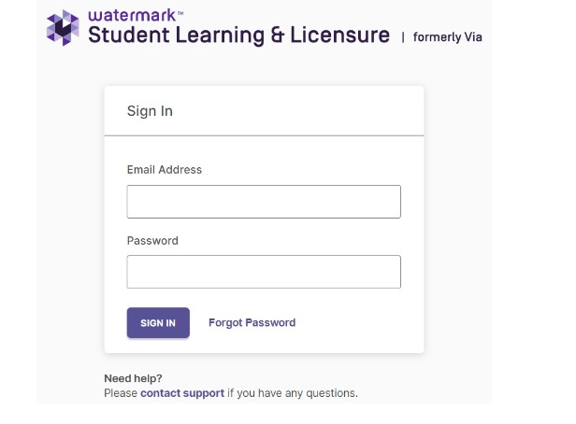
In Progress Tab
After logging in to Student Learning & Licensure (SL&L), the In Progress tab will be shown. The In Progress tab will list all of your active clinical practice or clinical internship courses (labeled Internship in Watermark). For each individual internship, submitted activities that are ready for assessment will be listed with the internship information.
TIP: If, within an individual internship, there is more than one activity ready for assessment, click the Expand button to see all activities.
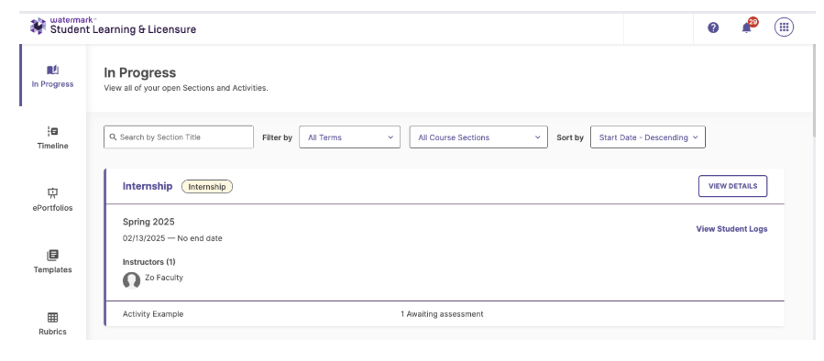
Internship Details Page
Clicking on an individual internship will open the internship details page. The internship details screen allows you to view the internship’s membership and activities. It features three tabs: Activities, Homepage, Student Logs, and Placement Details.
Activities
When the internship details page appears, the Activities tab is selected by default. The Activities tab displays all activities associated with the internship, including the details and assessment status of each activity.
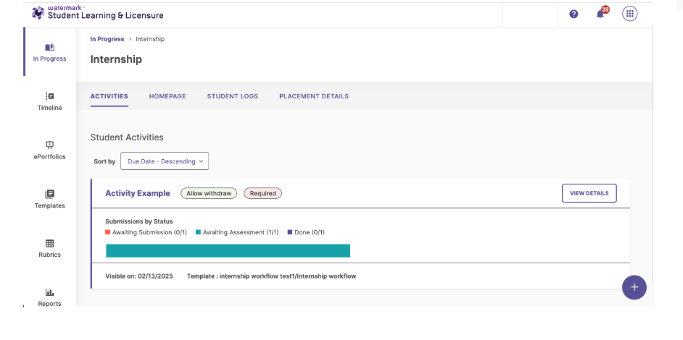
The Activity Details Page
When on the internship details page, clicking on an activity will display the activity details page. The activity details page shows the details of the activity, including the activity’s overall assessment status. This page also displays a list of all students of the internship, as well as each student’s individual submission and assessment status.
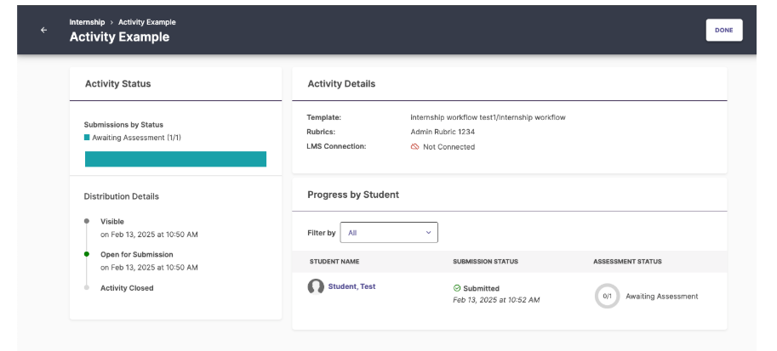
The Assessment Page
Assessment of member submissions takes place on the assessment page. The assessment page displays the member submitted template. This page also allows an assessor to score any rubrics included in the template, provide general feedback to the member, and type comments directly into the submitted template.
The assessment page is divided into two halves. The left side shows the template submitted by a member. The right side displays the Assessment Panel.
The Assessment Panel
The assessment panel occupies the right side of the assessment page. The assessment panel contains several components useful in assessing a submission, including any rubrics to be completed, or a Feedback text box for responding to a submitter.
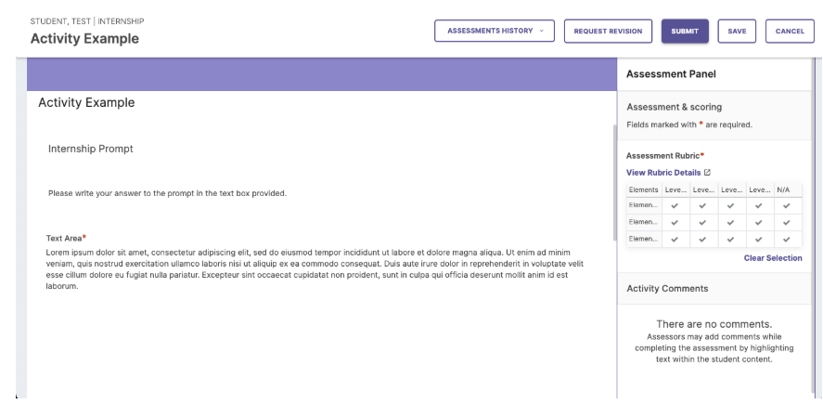
To assess a submission:
1. On the activity details page, click on the member to be assessed.
2. The assessment page will display, showing the submitted template.
NOTE: If the member is still in the Awaiting Submission column, the assessment page will appear, but no assessment will be possible.
3. To score a rubric, click on the desired description box for each element.
TIP: Hover over a description box to see the performance level, element name, and description.
TIP: The rubric can be expanded into a new tab. The expanded rubric shows all level and element names, as well as descriptions. To expand a rubric, click View Rubric Details.
The Submitted Template Area
The left side of the assessment page shows the template submitted by the member. Assessors can view member responses, download submitted attachments, and play included videos. Assessors are also able to comment on any individual part of the submitted template. When comments are added, they are displayed in the Comments List in the Assessment Panel.
To add a comment to a submitted template:
1. On the assessment page, double click or highlight any word or area in a submitted template.
2. Click the comment icon that appears.
3. Type a comment into the Comment text box.
4. When finished, click the checkmark icon.
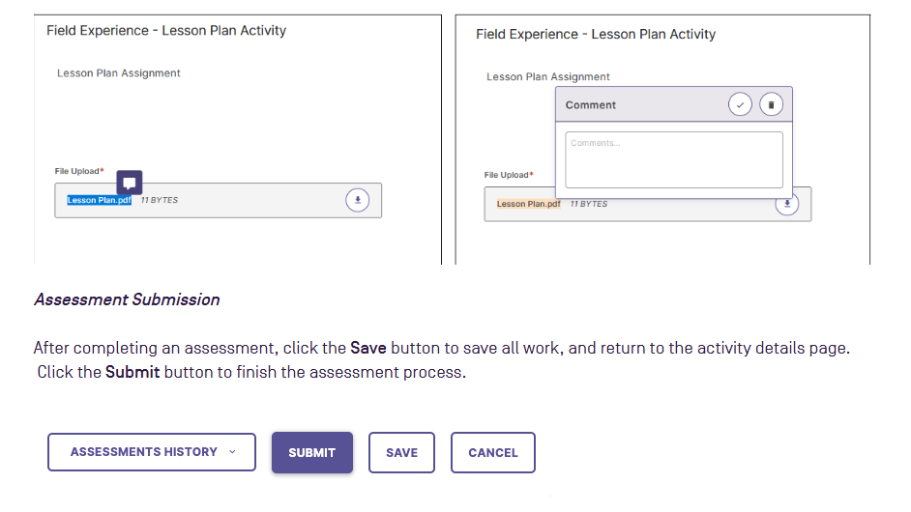
Student Logs
The Student Log allows an intern to record any tasks or events relevant to their internship. Mentors can view this time log, and approve or reject the intern’s entries (Note: entries can also be approved by the student's supervisor or instructor).
An internship’s time logs are viewed by clicking the Student Log tab on the internship details page. Alternatively, on the In Progress tab, an individual internship’s View Student Logs button will also open the Student Log tab.
NOTE: The Student Log feature is optional when administrators create internships. If there is no Student Log button or tab, the Student Log feature has not been enabled for the internship.
To view, approve, and reject time log entries:
1. On the In Progress tab, click an internship title.
2. Click the Student Log tab to view any interns who have recorded log entries.
3. To view an intern’s time log entries, click anywhere on the intern’s row.
4. On the intern’s log entries list, click either the check mark to approve, or the X mark to reject.

Getting Help
Watermark SLL Contact at USI:
- Dr. Simone Nance, Assessment Manager
- Email: senance@usi.edu
- Phone: 812-465-1607
- Office: Education Center 3134

Watermark Training Video Links
- Instructor Navigation Overview of Student Learning & Licensure (Video)
- Approve or Reject Student Time Log Entries
- Student Navigation Overview Video

