

REQUEST FOR PROPOSAL
Procurement Services
8600 University Blvd Information Technology Asset Management and System Imaging Software
Evansville, IN 47712-3597
Proposal No:  24-12-18039-03170  Due Date / Time:  4-02-2024 / 2PM / Local Time |  | Return to:  Jeff Sponn, Director of Procurement  University of Southern Indiana  Procurement  (Support Services Building)  8600 University Blvd  Evansville, IN 47712  jsponn@usi.edu

GENERAL INSTRUCTIONS TO PROPOSERS
USI Proposal form must be returned to:
PROCUREMENT, JEFF SPONN
jsponn@usi.edu

- Late submissions will NOT be considered in bid analysis.

Questions Due 3-18-2024 / 11AM / Local Time
Jeff Sponn, Director of Procurement
University of Southern Indiana
Email: jsponn@usi.edu

Answers Provided via Addendum by 3-21-2024

Due Date: 4-02-2024 / 2PM / Local Time

Insurance Certificate naming USI as “Additional Insured” and Workers Compensation, coverage is to be included in bid package.

For proposal results please view our website at www.usi.edu/procurement/competitive-bids-and-results

A. General Terms and Conditions

- Prices to include F.O.B. University of Southern Indiana

- Freight or other costs will not be allowed unless included in your proposal.

- Unless otherwise understood, there are no restrictions on the number of items or quantity that may be ordered.

- If alternates are offered, full descriptive information and literature must be submitted with proposal.

- The University of Southern Indiana is a political subdivision of the state of Indiana and is not subject to state sales tax. A tax exemption certificate will be sent upon request.

- Material Safety Data Sheets are to be submitted with your proposal for any applicable items or products.

- Terms/Shipping (VENDOR: PLEASE COMPLETE THE FOLLOWING)

  - Prices are firm for ____________ days
  - Expected terms are Net 30, if not, please indicate here: _________
  - Shipment to be made from _______________within_______days

- Minority Business Information (VENDOR: PLEASE COMPLETE THE FOLLOWING)

  - Is your business a certified minority?
Yes________ No_______

  - If yes, how certified: _______________________________

Company Name: _______________________________________

Authorized company signature: ______________________________________

Printed name: ________________________________________

For questions arising from this proposal request, please complete:

Contact Person Name: ____________________________________________

Contact Person Email: ____________________________________________

Contact Person Telephone: ____________________________________________

Nondiscrimination and affirmative action. This contractor and its subcontractor(s), if any, shall abide by the requirements of Indiana Civil Rights Act, IC 22-9, Executive Order 11246 and the Equal Opportunity clauses as set forth in 41 CFR §§ 60-1.4(a), 60-300.5(a) and 60-741.5(a). These regulations prohibit discrimination against qualified individuals based on their status as protected veterans or individuals with disabilities, and prohibit discrimination against all individuals with respect to his hire, tenure, terms, conditions or privileges of employment or any matter directly or indirectly related to employment, based on their race, color, religion, sex, sexual orientation, gender identity or national origin. Moreover, these regulations require that covered prime contractors and subcontractors take affirmative action to employ and advance in employment individuals without regard to race, color, religion, sex, sexual orientation, gender identity, national origin, protected veteran status or disability. As used herein, “contractor” shall be deemed to mean “Vendor” or “Supplier” and “contract” shall be deemed to mean this Agreement. The contractor will also comply with all applicable affirmative action reporting requirements. In addition, the contractor shall cause the Equal Opportunity clause references to be included in their subcontracts or purchases orders hereunder unless exempted by rules, regulations and orders of the Secretary of Labor issue pursuant to Section 201 of the Executive Order 11246 and 11375 as amended.

Signature 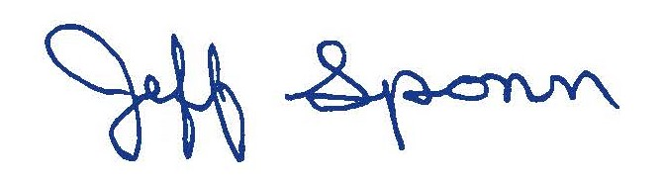 Date: 3-4-24
Jeff Sponn, Director of Procurement

