

March 6, 2023
Page 1 of 1

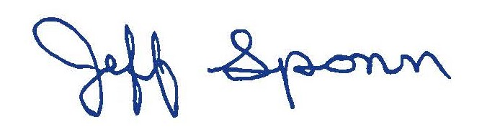
FROM: Jeff Sponn
Director of Procurement
812 464-1982
812 461-5275 Fax

SUBJECT: 23-7-32105-03000
University of Southern Indiana Pouring Rights
Due: 3-23-23 / 2PM/Local Time

Addendum #1

This addendum forms a part of and modifies bidding requirements that pertains to the above-mentioned project.

Bids will be due Thursday, March 23,2023 at 2PM Local Time.

All bidders shall acknowledge receipt of this addendum on the bid proposal form.

JS/bw

Procurement
8600 University Boulevard  Evansville, Indiana 47712  (812) 464-1847  FAX (812) 461-5275

