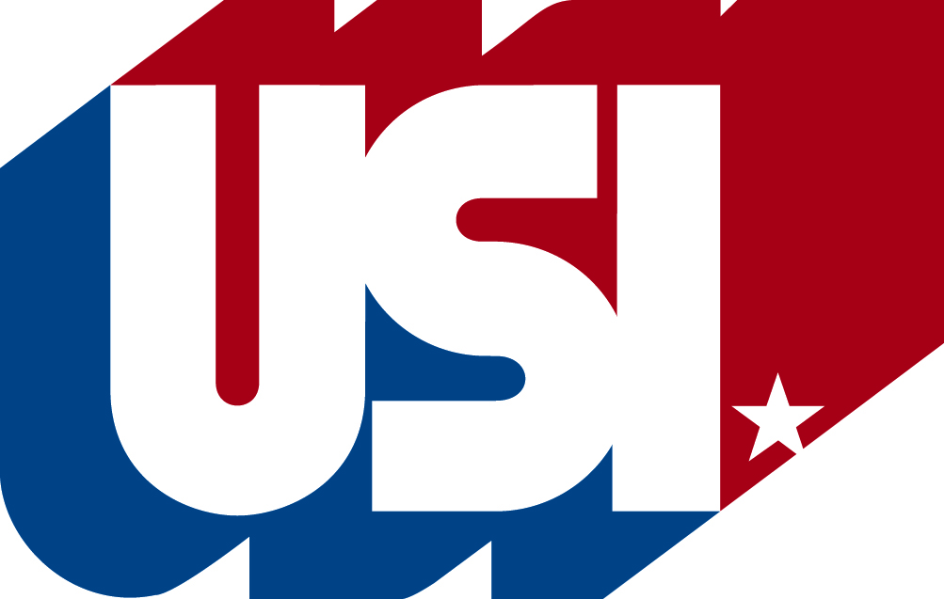

Bake Sale Safety Guide

Limit the bake sale menu to items which do not require refrigeration after preparation
–no cream or custard filled pastries or pies, cheesecakes, puddings, whipped cream, cream cheese.

Use only ingredients which are free of spoilage and come from licensed sources, like a grocery store. Home canned foods are not allowed.

Keep eggs and dairy ingredients refrigerated until use.

Clean and sanitize food preparation surfaces, utensils and equipment before beginning work.

Do not prepare or serve food when ill or recently ill (within 72 hours) with vomiting or diarrhea.

Before preparing any foods, wash hands thoroughly with soap and running water and dry with a paper towel. Repeat hand washing after using the bathroom, eating, smoking, changing diapers, caring for pets, or handling raw meat, poultry or eggs.

Whenever possible, wrap baked goods in individual servings for sale to the public.

Cover items that are not individually wrapped with plastic wrap, lids, or foil
to protect them from sneezes, coughs and handling by customers.

Use a napkin, utensil or disposable glove to serve items that are not individually wrapped.
Self-service of unwrapped/unpackaged items is not allowed.

Wash your hands before starting the sale and after doing anything that could contaminate them, such as coughing, sneezing, or eating.

The bake sale organizer should keep a list of bakers and the items they donated in case there is a need for follow up.

Donors are encouraged to identify/label products that contain any major allergen: peanuts/peanut butter, eggs, wheat, soybeans, milk and milk products and tree nuts (e.g. almonds, pecans, walnuts, cashews)

