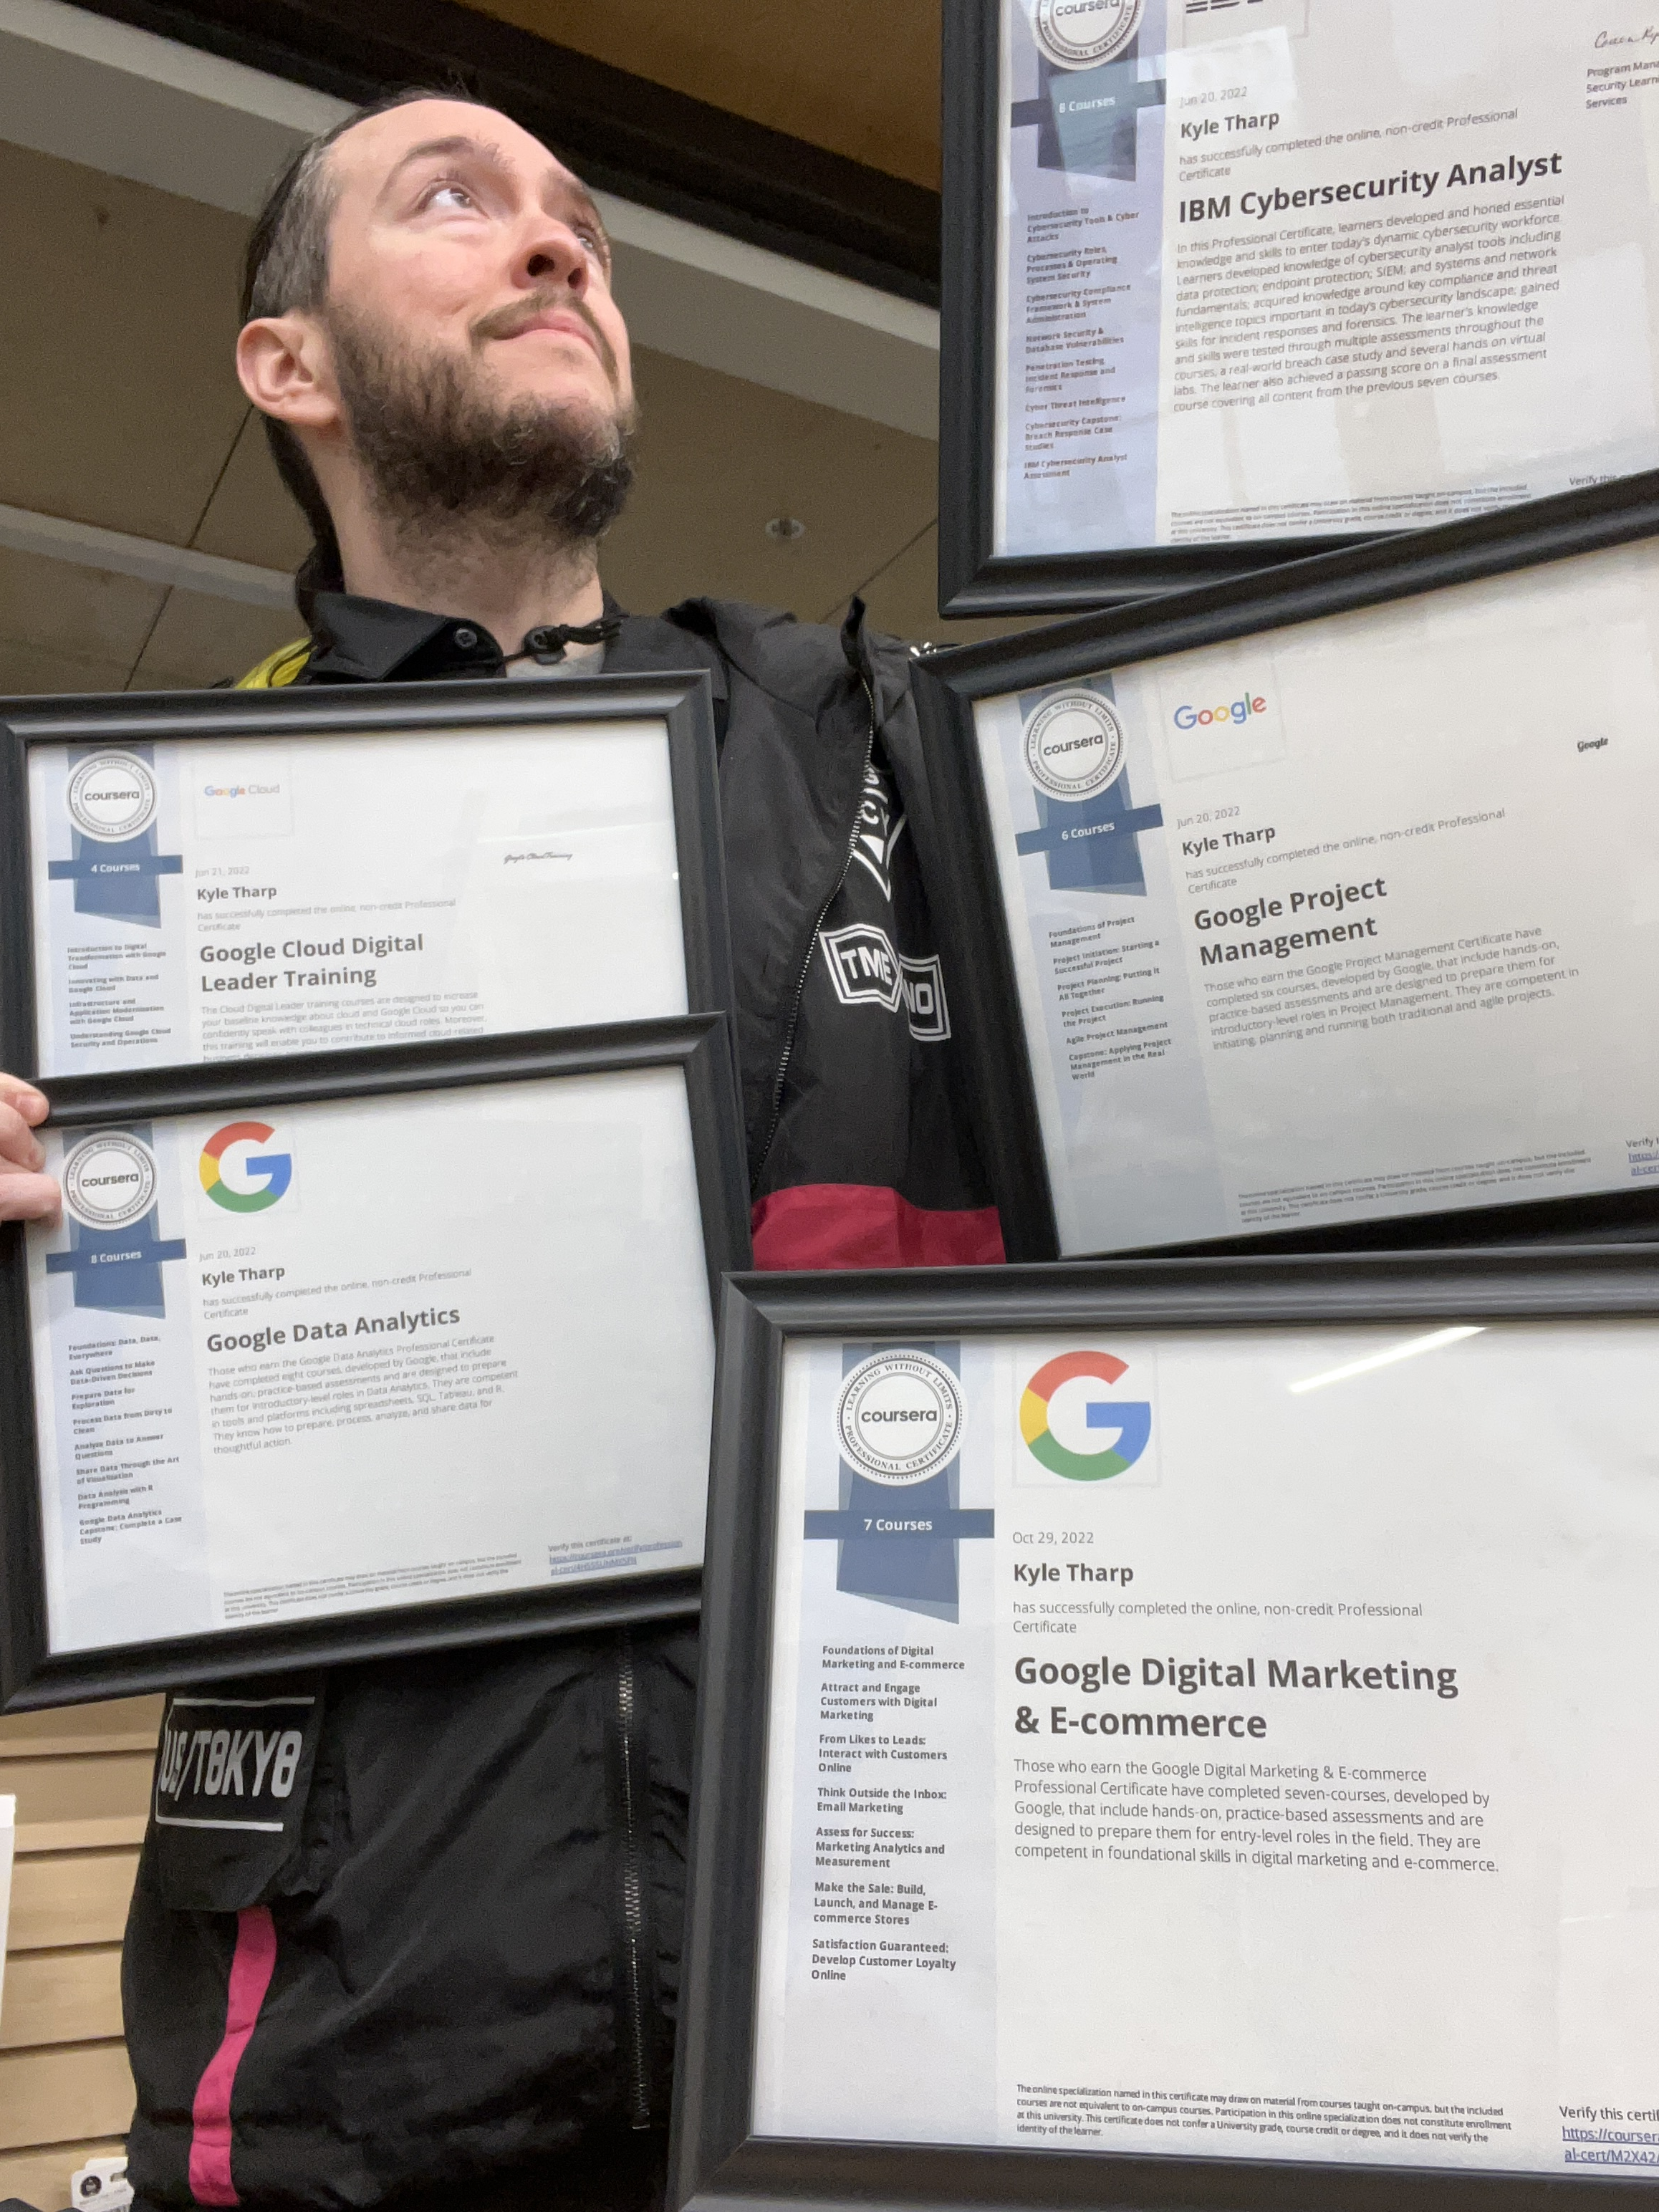 |  |  |  | Kyle  Tharp

Experience
June ‘22–Current
Adjunct Professor• CMST101 Public Speaking (Honors) • USI
Feb ‘20–Current
Senior Sales Architect• Enterprise/SMB • Computers Plus
Dec ‘18–Feb ‘20
Area Manager, Team Lead• EVS • Deaconess Hospital
May ‘16–Nov ‘18
GM, Chief Marketeer• OrgDev • Lucid Coffee
May ‘10–April ‘16
GM, Product Development• OrgDev • Vapor Bank/Frontier Liquor
Years of Business Development, Marketing, & Leadership Experience. College Professor, SMB Champion, & Six Professional Business Certifications.

Education
Masters- University of Southern Indiana, Evansville IN
- Organizational Communication, Quantitative Research
Bachelors- University of Southern Indiana, Evansville IN
- President of Student Communication Organization
- National Communication Association – Top Paper Student Division
- National Communication Association – Featured Panelist, Mentorship

Certifications
Google – Digital Marketing & E-commerce
Google – Data Analytics
Google – Project Management
Google Cloud – Digital Leadership
IBM – Cybersecurity Analyst
Meta – Marketing Analytics

Academic Accomplishments
National Communication Association – Top Paper, Student Division
“The Effects of Verbal Aggression on Cognitive Development”
National Communication Association – Featured Panelist ft. Dr. Bill Rawlins & Dr. Stephanie Young, “Mentorship”
National Communication Association – Student Organization of the Year, President of Student Communication Organization (USI)
Master’s Thesis – “Run for Your Life: An Autoethnography”

References
Dr. Stephanie Young – USI – slyoung@usi.edu
Dr. Leigh Anne Howard – USI – lahoward@usi.edu
Dr. Wes Durham – USI – wdurham@usi.edu

1937 Cheyenne Dr.
Evansville, IN 47715
 |  | 812-568-7472
 |  | kbtharp@usi.edu
 |  | Justkyron.com

