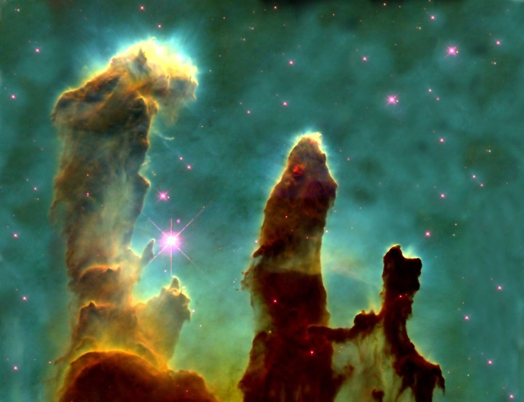
Syllabus

Physics 175 – Fall 2017

The Course: Physics 175 is the first course of a 2-semester sequence of algebra and trig-based general

physics. This course is offered for science and other pre-professional majors. The main topics to be covered are motion, forces, work and energy, momentum, fluids, and thermodynamics.

Core Curriculum: Physics 175 fulfills a Bachelor of Arts or Science requirement of the University of Southern Indiana’s Core 39 program as a Natural Science with a Lab.

The Instructor: Dr. Kent W. Scheller Office Phone: 464-1903
email: mailto:kschelle@usi.edu
Office: SC 2223 Education: Ph.D., Notre Dame, 1994
Website: http://faculty.usi.edu/kschelle
Bats: Right Throws: Right Team: Atlanta Braves
Height: 5’10” Weight: 190 lbs Education: Ph.D., Notre Dame
Marital Status: Married (Amy) Children: Nicholas (19), Abby (13), Jacob (11)

Course objectives
- To gain exposure to basic physical principles and appreciate their connections to other fields of science
- To experience thinking logically and critically about the world around us, and to communicate this thinking, both orally and in writing, through descriptive and mathematical techniques
- To increase our understanding of the scientific method and the nature of physical law

Upon Completion of Physics 175, students will be able to
1. Describe the roles of observation, hypothesis, and testing in the process of
generating and modifying scientific explanations.

2. Demonstrate the ability to use appropriate discipline-specific observational,
quantitative, or technological methods to test hypotheses and determine their
potential validity.

3. Apply foundational knowledge and discipline-specific models and/or theories to
explain or predict natural phenomena and to solve problems in motion, forces, work and energy, momentum, fluids, and thermodynamics.

4. Locate reliable sources of discipline-specific scientific evidence to construct
arguments related to real-world issues and, where appropriate, distinguish between scientific and nonscientific evidence and explanations.

The Book: Physics, 7th Edition, Giancoli AND subscription to Mastering Physics

The Attendance Policy: Class attendance is required. Attendance for lab sessions is mandatory and 80% of the lab reports must be turned in to obtain a passing grade in the course AND a score of 75% or better must be earned to get a passing grade in the course.

The Grade: There will be 4 one-hour exams and a comprehensive final exam. The lowest one-hour

exam score will be dropped. The course grade will be determined in the following manner based on total points possible:

3 one-hour exams(Four, less the 1 you drop) 300 points

Homework ~100 points
In-Class Exercises 50 points

Lab grade 100 points

Final exam 100 points ~650 Points

From this total: 90%=A, 80% =B, 70%=C, 60%=D, and below 60% = F

THERE ARE NO MAKE-UP EXAMS. IF YOU MISS AN EXAM, THAT IS YOUR DROP TEST.

THERE ARE NO + OR – GRADES

LAB POLICY
The compiled laboratory grade will be calculated on the basis of all scheduled laboratory exercises and associated materials; students are not allowed to drop any of these elements. A laboratory grade that is greater than 70% is considered passing (“P”). You may “carry” that grade forward should you need to retake the lecture in the future. A lab grade lower that 70% will earn you an ‘NP’ grade for the lab section and will automatically fail you from the course due to your unsatisfactory performance in a crucial component of the course.

The Withdrawal Policy: Conforms with University Policy. https://www.usi.edu/registrar/schedule-changes/withdrawal

The Policy/Penalty for Academic Dishonesty (link) : https://www.usi.edu/media/3563761/Academic-Integrity-Policy-Interim-Fall-2014.pdf

ADA Policy: If you have a disability for which you may require academic accommodations for this class, please register with Disability Resources (DR) as soon as possible. Students who have or who receive an accommodation letter from DR are encouraged to meet privately with course faculty to discuss the provisions of those accommodations as early in the semester as possible. To qualify for accommodation assistance, students must first register to use the disability resources in DR, Orr Center Rm. 095, 812-464-1961 http://www.usi.edu/disabilities. To help ensure that accommodations will be available when needed, students are encouraged to meet with course faculty at least 7 days prior to the actual need for the accommodation.

Agenda Fall 17
Date | Agenda | Problems
Aug 21 M | Chapter 1, Chapter 2
23 | Chapter 2
25 | Chapter 2
28 M | Chapter 3
30 | Chapter 3
Sept 1 | Chapter 3
4 M | No class - Labor Day
6 | Review
8 | Test #1
11 M | Chapter 4 Forces
13 | Chapter 4
15 | Chapter 4
18 M | Chapter 5 Circular Motion
20 | Chapter 5
22 | Chapter 5
25 M | Chapter 6 Work and Energy
27 | Chapter 6
29 | Chapter 6
Oct 2 M | Review
4 | Test #2
6 | Chapter 7 Impulse & Momentum
9 M | Fall Break
11 | Chapter 7
13 | Chapter 7
16 M | Chapter 8 Rotational Motion
18 | Chapter 8
20 | Chapter 8
23 M | Chapter 10 Fluids
25 | Chapter 10
27 | Chapter 10
30 M | Review
Nov 1 | Test #3
3 | Chapter 13 Temp and Kinetic Theory
6 M | Chapter 13
8 | Chapter 13
10 | Chapter 14 Heat
13 M | Chapter 14
15 | Chapter 14
17 | Chapter 15 Thermodynamics
20 M | Chapter 15
22 | Thanksgiving Break
24 | Thanksgiving Break
27 M | Chapter 15
29 | Review
Dec 1 | Test #4
Dec 4 M | Review
Dec 13th | FINAL EXAM 9-11 AM

